# PF LAB (STRUCTURES)

# NAME: Mehreen Fatima

# SAPID: 63255

# TASK 1:

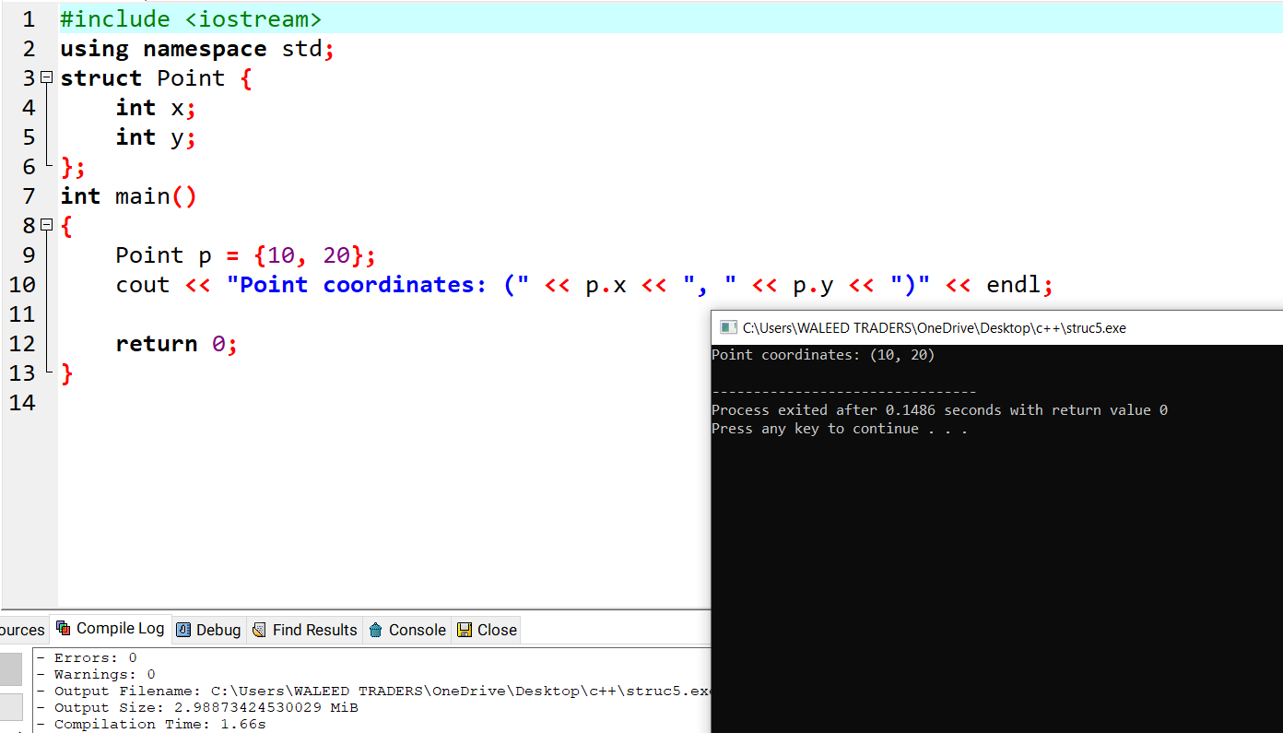

# TASK 2:

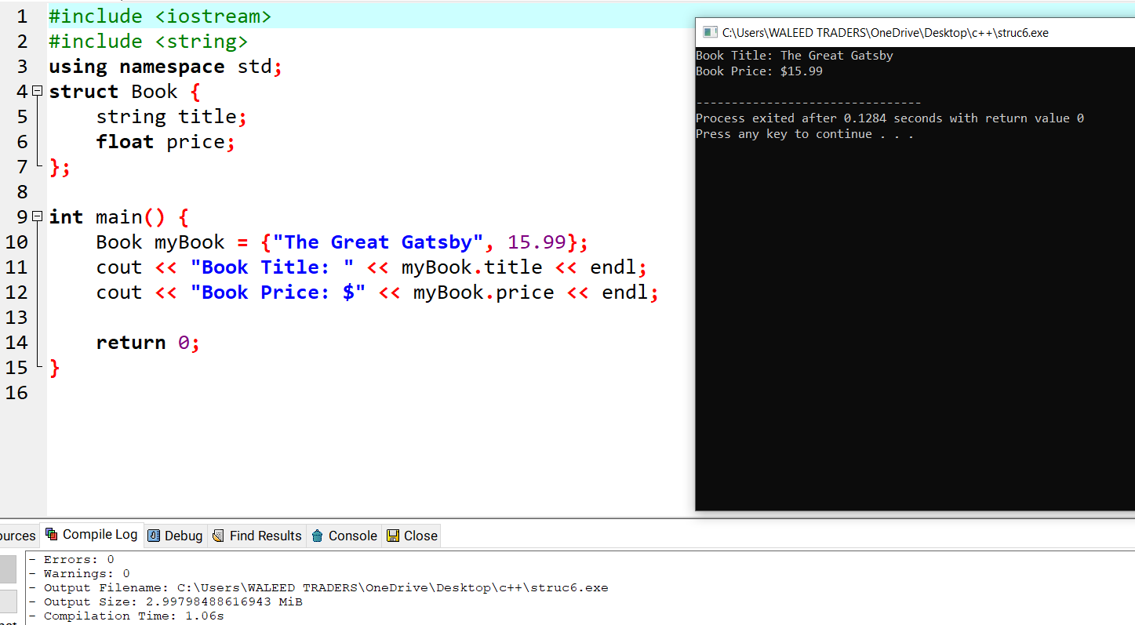

# TASK 3:

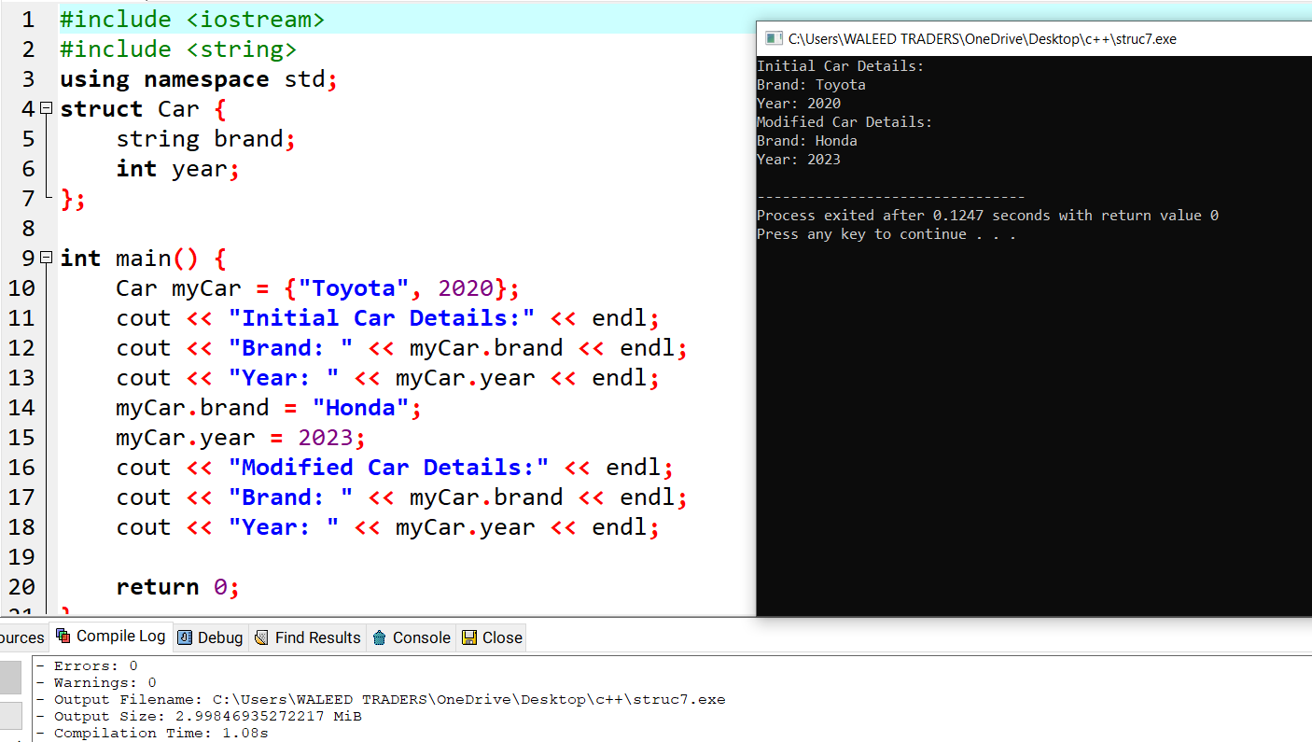

# TASK 4:

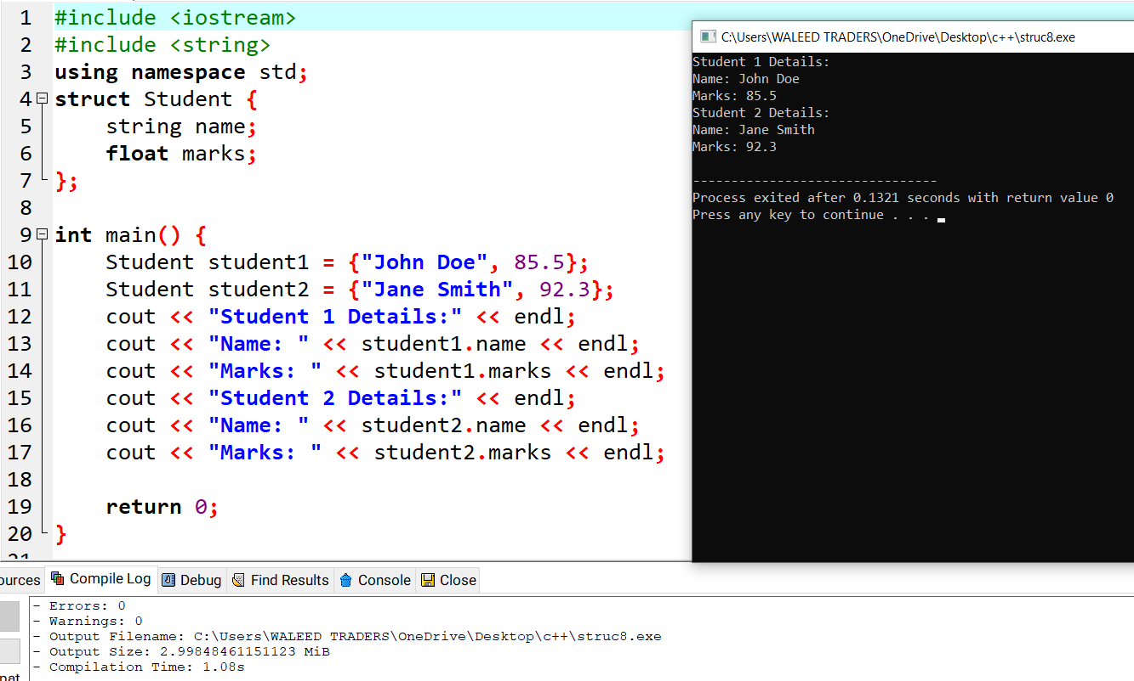

# TASK 5:

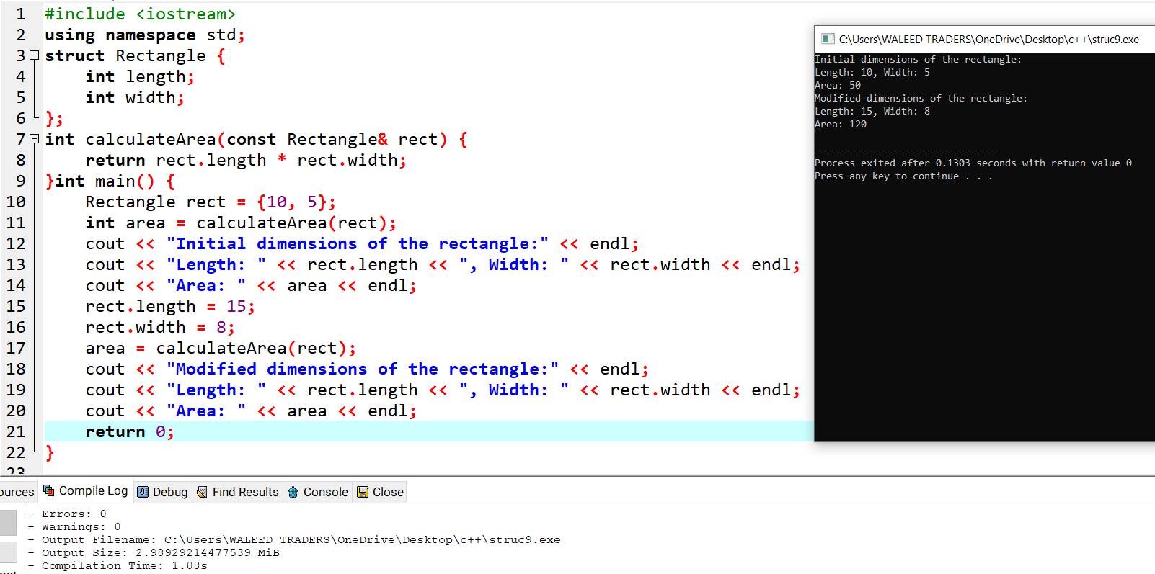

# TASK 6:

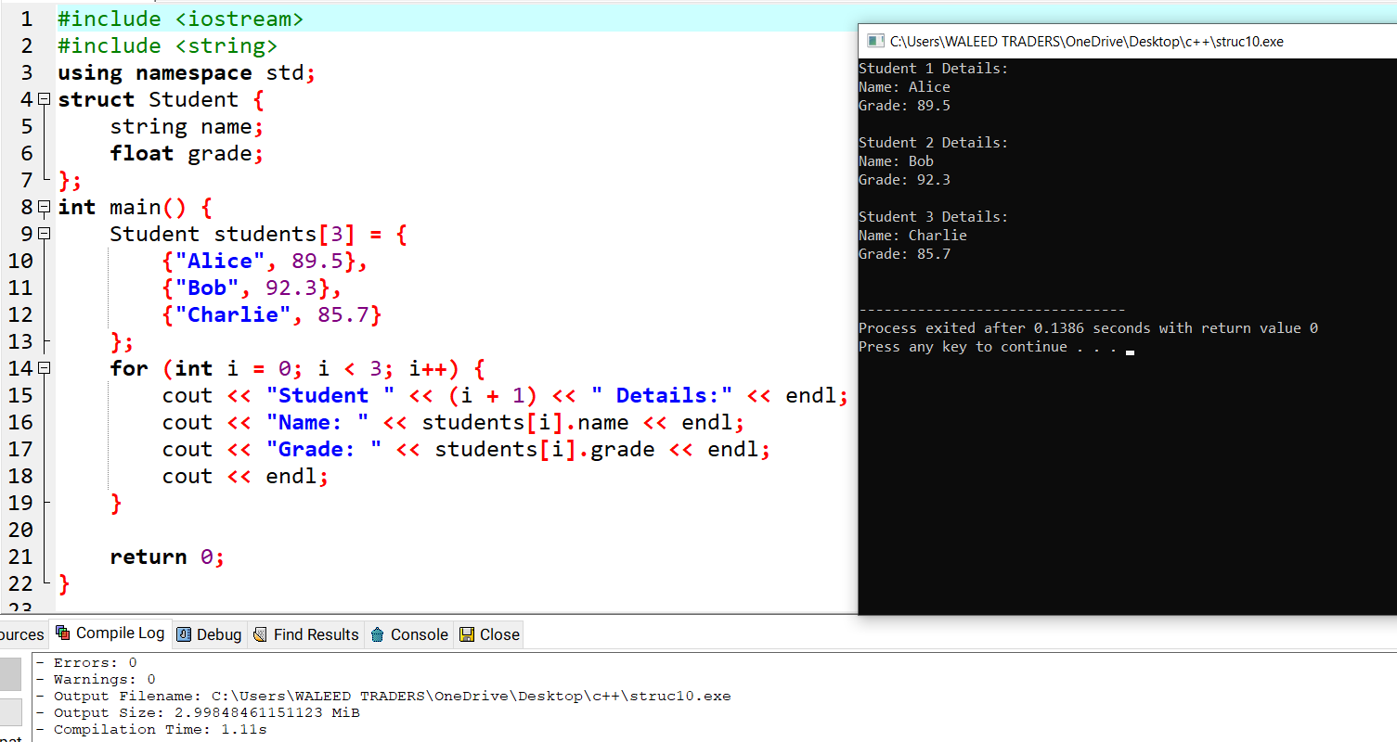

# TASK 7:

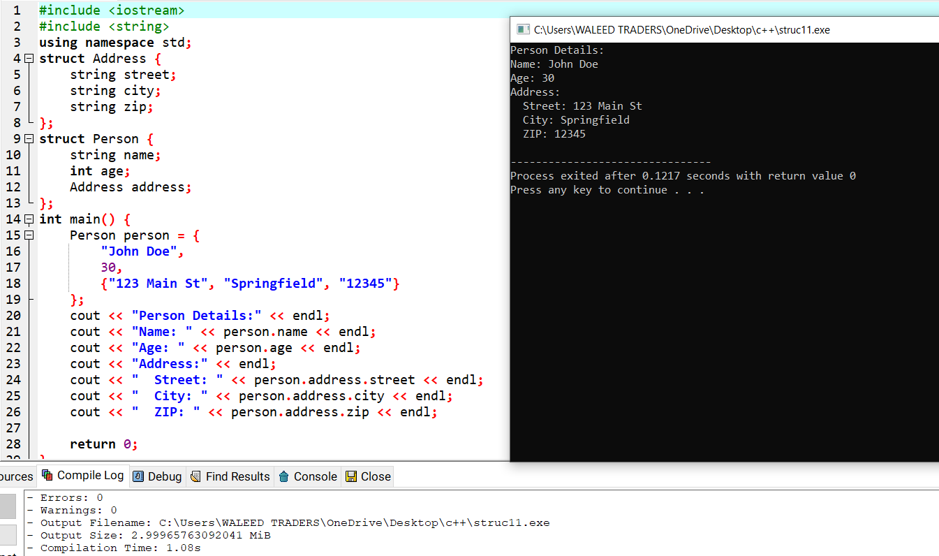

# TASK 8:

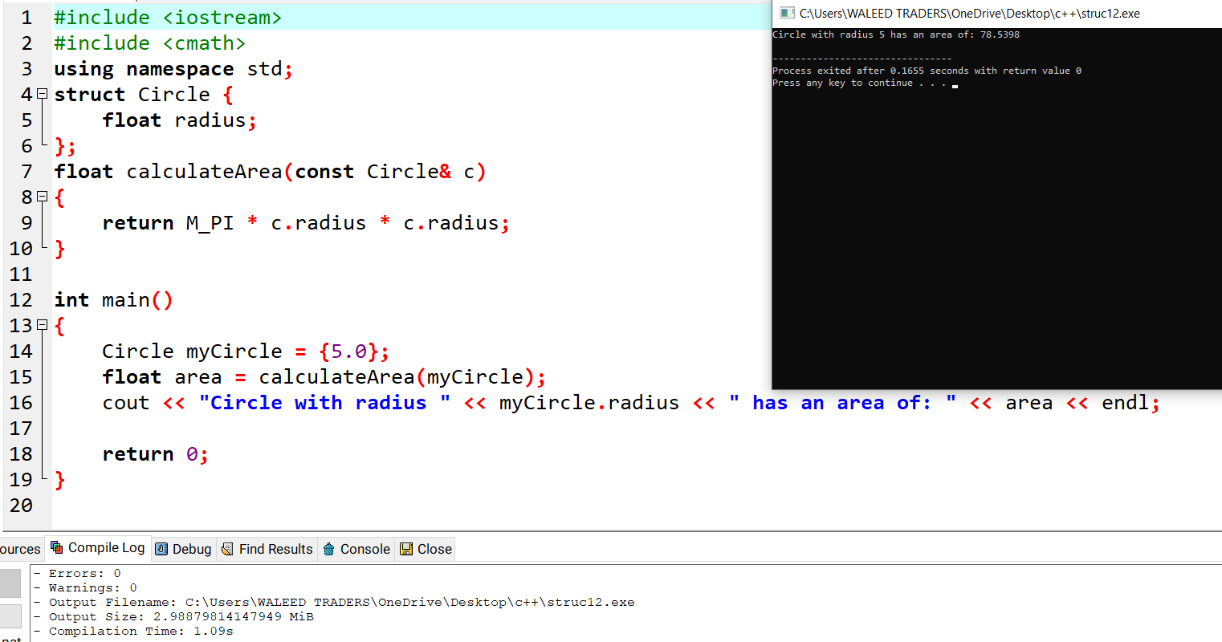

# TASK 9:

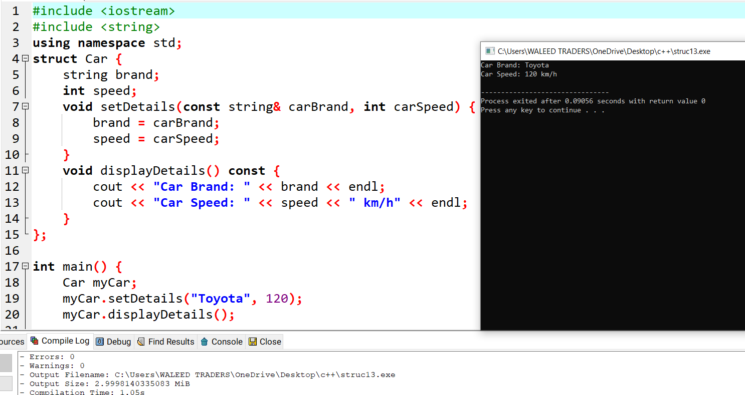

# TASK 10:



